**React JS**

**Prerequisites:**

* HTML
* CSS
* JavaScript ES6

**Topics**

* What is React?
* Why React?
* Difference between React, Angular, Vue etc.
* Features and Limitations
* Understanding React Application Architecture
* Components, Props and State
* Styling with Material UI
* Debug React Apps
* Life Cycle
* React Hooks
* Ajax Calls / Http Requests
* Integration with Server Side [MERN]
* Routing
* Forms and Validations
* Deploying
* Redux
* Error Handling
* Unit Testing
* Web Pack
* React Native
* End to End Integration

Which one I have to choose? [Angular or React]

Projects – Which are completely integrated with lot of server-side interactions and every concept is handled at server level only they are looking for good UI to make faster interactions then “React JS”.

Projects – Which need to control their application flow both client side and server side – Angular.

React JS is library

Angular is Framework

Mill of Users are accessing some content using content. Only few interactions like message, chat. Not complete EPR. [Not Querying – Transactions, complex operations] – React is Great

Twitter, Instagram

Java - Spring

PHP - Cake PHP, Code Igniter

Python - Django, Flask

Ruby - Ruby on Rails

.NET - ASP.NET MVC

JavaScript - SPINE, Angular

**MVC – Model View Controller**

React is only with “View” UI – Interactions

Web Development 3+ Years: Angular, React

Java, .NET, PHP, Python 3+ years [Angular, React]

**What is React and How it Works?**

* React JS is a library.
* Client Side we have languages, libraries and frameworks.
* **Client-Side Languages**
  + JavaScript
  + TypeScript
* **Client-Side Libraries** 
  + jQuery
  + RxJS
  + jQlite
  + React JS
* **Client-Side Frameworks**
  + Angular JS
  + Knockout JS
  + Backbone JS
  + Angular

**What is difference between Language and Library?**

* Language requires functions defined explicitly to handle various interactions.
* Language requires lot of references.
* Library is a set of factories.
* Factory is a set of pre-defined functions.
* You can implement the existing function and define the functionality.
* Library reduces the compatibility issues.
* React JS is a library.

**What is difference between Library and Framework?**

* Library can build application.
* Library is passive [not-active]
* Library can’t control the application flow.
* It requires browser events to make library active.
* Framework is a software architectural pattern that provides set of libraries to build application and can also control the application flow.

**What is React JS?**

* React JS is a JavaScript library.
* Building User interfaces and handling User interactions client side.
* Facebook – Jordan Walke – for building SPA.
* 2013 Initial release.
* 2020 – 17.0.1 latest stable version.

**It is not designed for what you are using. Hence limited library.**

**React JS library requires several external libraries to integrate and handle functionality.**

**Features of ReactJS**

* ReactJS uses virtual DOM that makes the user experience better.

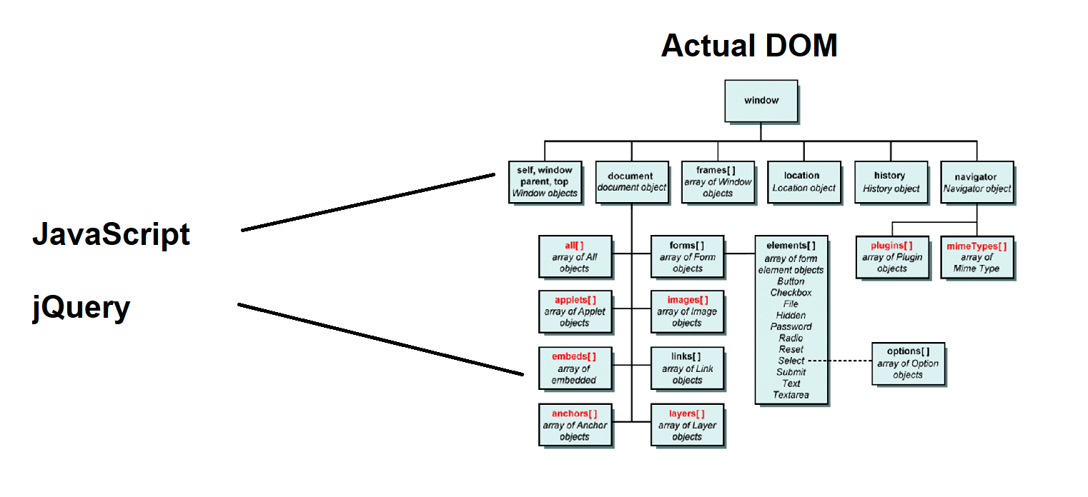

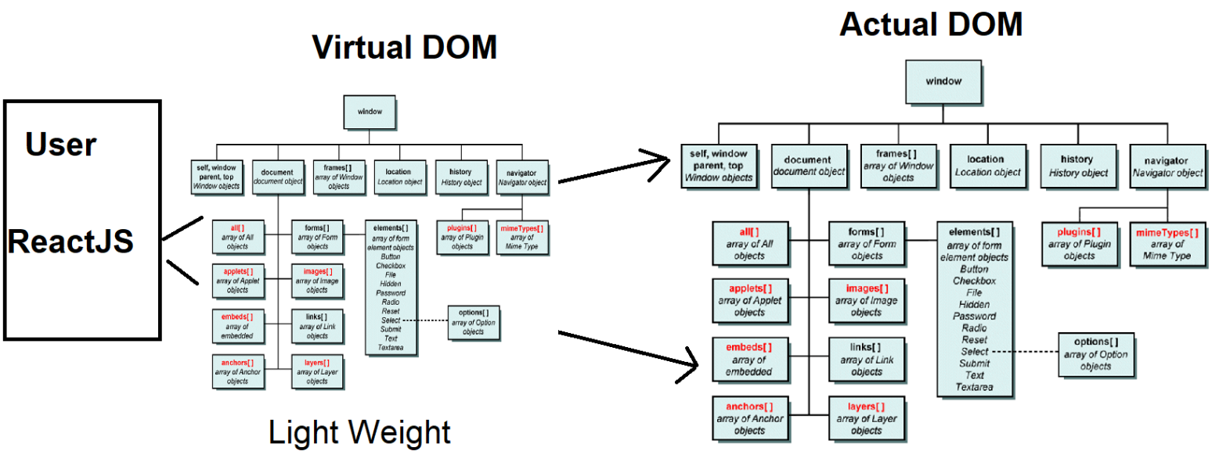

* Faster Interactions.
* React uses JSX, which is easy to handle the manipulation on DOM elements.
  + JSX is faster that JavaScript DOM manipulations.
  + Logic and markup can be defined in single file.
  + It is easy to create template.
  + Template comprises of presentation and logic.
* React uses “One Way Data Binding”
  + Data binding is a technique used to update the component data to View [UI]
  + Any change in component data will update to UI. [HTML]
  + Changes made in UI are not directly update back to component, they are handled on virtual DOM.
* Component based architecture.
  + It is an alternative for legacy type library.
  + It is more asynchronous
  + It loads only what is required for the situation.
  + It improves the performance of application.
  + It makes your library modular.

**Concerns with ReactJS**

* Very high pace of development.
* Problem for developers to catch and update the pace of developing features.
* Poor documentation.
* Poor SEO
* JSX [Presentation with Logic] – Insecure content and ignore   
  XSS [Cross Site Scripting Attacks]
* Need lot of external libraries to handle various interactions.

**Setup Environment for ReactJS**

**Install Node JS**

* + Node JS provides a package manager NPM.
  + Package manager is a tool used to install and configure library required for our application.
  + There are several package managers like: Yarn, NPM, Bower, Ruby Gems, NuGet etc.
  + Installing Node JS on your PC will get you NPM.   
    <https://nodejs.org/en/download/> [Make sure that Node JS version 10+]
  + After installing Node JS check the version from command prompt   
    > node -v   
    > npm -v

**Install Visual Studio Code [IDE – Integrated Development Environment]**

* IDE provides environment to build, debug, test and deploy application.
* You can use various editors: “editorconfig.org”
* Download and install VS Code  
  <https://code.visualstudio.com/>
* Go to “Customize” and “Install Support for JavaScript”
* Go to “Extensions” and Install following
  + **Live Server:** It required to preview your application.   
    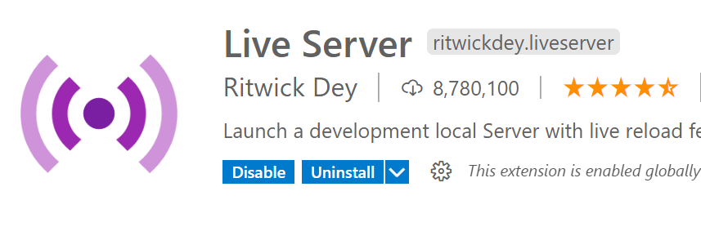
  + **Vscode-icons:** It gives suitable icons for specific file extensions and names, so that developer can easily identify the file type.   
    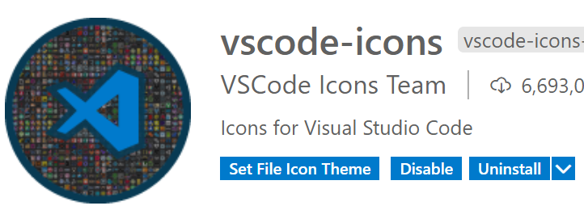
  + **IntelliSense for CSS Class Name:** It provides help on CSS  
    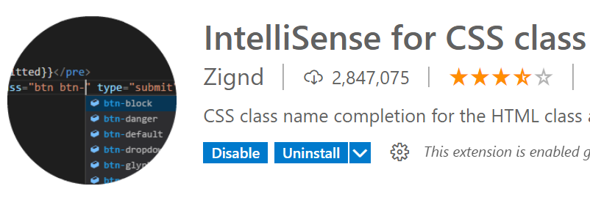

**Creating a new Project**

* Create a new folder for project by name “ReactApp” on your PC   
  **“C:\ReactApp”**
* Open your folder in Visual Studio Code: File Menu -> Open Folder -> C:\ReactApp
* Open Terminal: Go to Terminal Menu and select “New Terminal” or Ctrl + ` [backtick]
* Run the command “npm init”  
  **C:\ReactApp> npm init**
* It will generate “package.json” that comprises of project meta data.

*package name: (reactapp) reactapp*

*version: (1.0.0)*

*description: This is our first react application*

*entry point: (index.js)*

*test command:*

*git repository:*

*keywords: react shopping, smart shopping*

*author: Naresh I Technologies*

*license: (ISC) MIT*

* **Install React Modules into Project**C:\ReactApp>npm install --save react  
  C:\ReactApp>npm install --save react-dom
* Installed library will be maintained in “**node_modules**” folder

**Create a React Application**

> npm install -g create-react-app

> create-react-app shopping  
> Change to shopping   
 C:\reactapp\shopping>

> **npm start** [Start the react application]